Minutes: Triangle OA Intergroup Meeting
Saturday, March 25, 2023—10:15am to 12:00pm

Approved, with minor corrections 5/20/23

Attendees
Zach P (Group Outreach), Laura (Wilmington Wed), Karen (Vice-Chair/SOAR), Neill (WSBC), Mary Anne (Treasurer), Colleen - had to leave reported via text (Newsletter Editor, Durham Sat), Liz V (PIPO, Raleigh Tue Eve), Jessie (Hillsborough Wed Eve), Dana (Secretary, Durham Sun), Heather (Hi-Tech, Carrboro Sun Afternoon), Kathy (Chapel Hill Tue Eve), Anne (Chair), Cynthia R and Margaret.

Review and Approve Minutes
The January meeting minutes were reviewed and approved.

Treasurer’s Report (Mary Anne, submitted electronically)
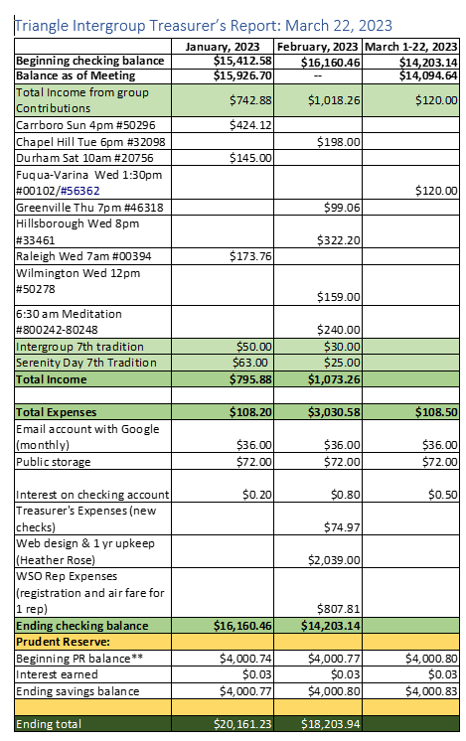
- Liz reimbursed for chair budget for purchases.
- Treasurer Report reviewed and approved.

Standing Committee Reports (5 minutes each)
Secretary (Dana) - None
WSO (Neill, Cheryl) – Neill reported WSBC 4/25-30 in NM, reservations confirmed. Neill presenting with another fellow. Working on development of groups for young people. Mary Anne (outgoing) did complete project that allows a group to query how welcoming you are to diverse participants. Pending approval and distribution.
SOAR (Colleen. Karen) – Colleen provided report provided SOAR business conference. Karen assigned to PIPO group, discussing ways to share information.
High Tech (Heather) – Tour of new website TriangleOA.org. All features working – want to implement use of blog. Will need a regular schedule for posting.
Group Outreach (Zach) – Let him know of website updates. Rocky Mount was not able to get off the ground.
Newsletter (Colleen) – Will send April once minutes received. Needs groups to write June and beyond. Sat am Raleigh volunteered for June.
Public Information/Professional Outreach (Liz V.) – Ordered some materials and have identified some practices to share with. Bulletin board sticky notes can have Intergroup information listed. Idea for a PIPO calendar of types of tasks to complete. Wants to develop a Fall event. Working with Molly to collaborate. Possible outreach to the Atlanta Intergroup with ideas. Karen can pass over information learned.

Ad Hoc Committee Reports – (3 minutes each)
12 Step Within (Mel, Diane) – Virtual workshop Grounded Through the OA Tools 4/22 1-3p.
Bylaws/Policy and Procedures (On hold for now)

Announcements
- Upcoming Region 8 virtual workshop “Abstinence” 5/21 3-5p – 3 speakers. Translated into Spanish and Portuguese. Neill will send more information and will be posted on TriangleOA.org.

Business

Terms of Service:

Should we consider making board members and possibly some or all committee chairs 2-yr terms? Half to be elected each year?
- Pros – Allows for people to better understand and learn the role and make a difference in the position.
- Cons – Want to get new people involved in serving.
- Considerations – Not have Treasurer and Chair changing on same year.
Mary Anne and Anne will create a motion for vote next meeting.

12th Step Within Committee status:
Motion to move TSW to a standing committee, and not ad hoc? Approved.

Zoom Account Log In:
Currently, the Chair and High-Tech Chair have the Zoom log-in credentials, but as TSW uses the Zoom account for serenity day events that use a waiting room (so the meeting must be opened by someone using our Zoom account), it seems logical that the TSW chair should have it as well. Any objection? Approved.

Review for IG Reps
- Reminder to provide Intergroup with changes in your meeting, including type hybrid etc. For proper representation on website.
- Check out the new website www.TriangleOA.org.
- Upcoming Virtual Events
  - 4/22 1-3p Grounded Through the OA Tools – posted on website.
  - 5/21 3-5p Abstinence – coming soon to website.
- Still need groups to write for Newsletter – July and beyond.

